**  
Kerb Block Memorial**

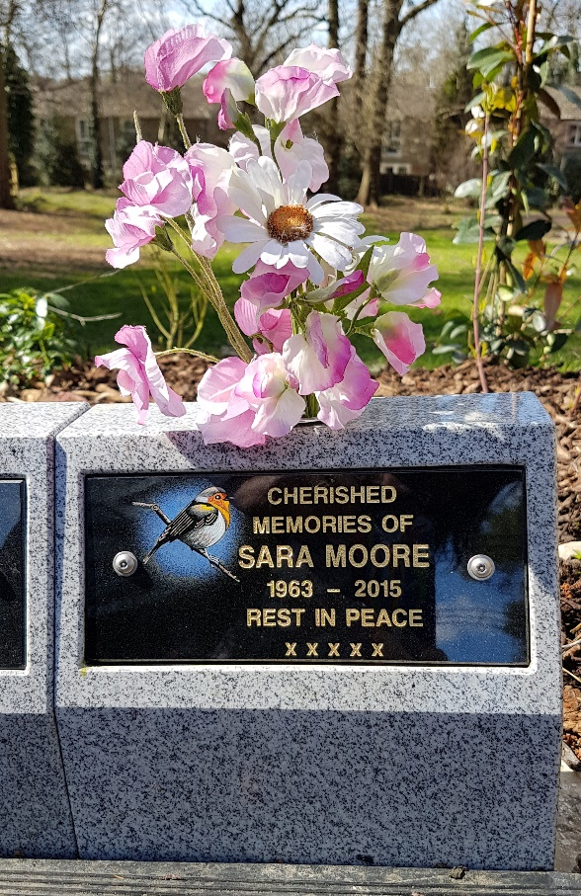

The kerb block memorials which are located around the Garden of Remembrance pathways will be leased for 25 years. The ashes can be either buried loose behind the memorial or buried or scattered in our dedicated area. The memorial has a small vase for a posy of flowers.

On completion of the term of the lease, the owner will have the option to extend. The inscription tablet will remain the property of the family but will be removed on completion of the lease and stored if the family cannot be contacted.

We would respectfully ask that you do not place additional items, vases, etc. on or near the vaults. Any such items will be removed and placed in the central shelter for collection for a period of six months.

**---------------------------------------------------------------------------------------------------------**

**Your inscription for the Kerb Plaque**

**Tablet 8” x 31/2”**

**Can be with portrait design or 4cm by 3cm photo plaque**

|  |  |  |  |  |  |  |  |  |  |  |  |  |  |  |  |  |  |  |  |  |  |  |  |
| --- | --- | --- | --- | --- | --- | --- | --- | --- | --- | --- | --- | --- | --- | --- | --- | --- | --- | --- | --- | --- | --- | --- | --- |
|  | 1 | 2 | 3 | 4 | 5 | 6 | 7 | 8 | 9 | 10 | 11 | 12 | 13 | 14 | 15 | 16 | 17 | 18 | 19 | 20 | 21 | 22 | 23 |
| Line 1 | P | H | O | T | O | / |  |  |  |  |  |  |  |  |  |  |  |  |  |  |  |  |  |
| Line 2 | D | E | S | I | G | N |  |  |  |  |  |  |  |  |  |  |  |  |  |  |  |  |  |
| Line 3 |  |  |  |  | T | O |  |  |  |  |  |  |  |  |  |  |  |  |  |  |  |  |  |
| Line 4 |  |  |  |  | G | O |  |  |  |  |  |  |  |  |  |  |  |  |  |  |  |  |  |
| Line 5 |  |  | H | E | R | E |  |  |  |  |  |  |  |  |  |  |  |  |  |  |  |  |  |
| Line 6 |  |  |  |  |  |  |  |  |  |  |  |  |  |  |  |  |  |  |  |  |  |  |  |

1. No more than one letter or number must be written in a box
2. Do not forget to add spaces in your inscription. A space counts as a letter or number
3. The text will be centered on the tablet – this guide box is only to aid your choice of inscription
4. Blacked out boxes are to represent holes for the tablet to be fixed to the memorial – Do not use
5. The inscription must be clearly written in block capitals as we are unable to accept responsibility for any incorrect inscription due to illegible or ambiguous writing





A full range of artwork designs are available - floral, hobbies, animals, sports. We can also provide bespoke artwork based on your design in order to recognise a special interest, celebration or passion of your loved one. Award winning artists and craftsmen ensure your design is reproduced to the highest standard

The photo plaque allows you to create a personal legacy when you add ceramic portraits to your tribute. The high-quality process ensures that the ceramic cameos retain their beauty indefinitely.

The Kerb block memorial can be leased 25 years with an option to extend after that.

**-------------------------------------------------------------------------------------**

**Your details**

**I would like to lease a Kerb Memorial Block for a period of 25 years and include payment.**

**I understand that flowers may only be placed in the vase provided and that any other flowers, plants or items left on the Kerb block will be removed. Anything placed on the granite could damage the porous surface.**

**I agree that at the end of the lease period, if no contact can be made with the family, the plaque will be removed from the block and stored.**

|  |  |  |
| --- | --- | --- |
| **Name** |  |  |
| **Address** |  |  |
| **Phone** |  |  |
| **Email** |  |  |
| **Signature** |  |  |
| **Date** |  |  |
| **Plot Number** |  |  |

**Please return to the cemetery clerk at Fleet Town Council, The Harlington, 236 Fleet Road, Fleet GU51 4BY. 01252 625246** [**cemetery.clerk@fleet-tc.gov.uk**](mailto:cemetery.clerk@fleet-tc.gov.uk)

HSBC Bank, Account name Fleet Town Council, sort code 40-21-27, account number 61539272. Please put your name or memorial number if known as reference

**Flat Kerb Memorial**

The kerb block memorials which are located around the Garden of Remembrance pathways will be leased for 25 years with an option to extend after that.

The ashes can be either buried loose behind the memorial or buried or scattered in our dedicated area. The memorial has a vase for flowers.

On completion of the term of the lease, the owner will have the option to extend. The inscription tablet will remain the property of the family but will be removed on completion of the lease and stored if the family cannot be contacted.

We would respectfully ask that you do not place additional items, vases, etc. on or near the blocks. Any such items will be removed and placed in the central shelter for collection for a period of six months.

**---------------------------------------------------------------------------------------------------------**

**Your inscription for the Plaque**

**Can be with design or photo plaque**

|  |  |  |  |  |  |  |  |  |  |  |  |  |  |  |  |  |  |  |  |  |
| --- | --- | --- | --- | --- | --- | --- | --- | --- | --- | --- | --- | --- | --- | --- | --- | --- | --- | --- | --- | --- |
|  | 1 | 2 | 3 | 4 | 5 | 6 | 7 | 8 | 9 | 10 | 11 | 12 | 13 | 14 | 15 | 16 | 17 | 18 | 19 | 20 |
| Line 1 | P | H | O | T | O | / |  |  |  |  |  |  |  |  |  |  |  |  |  |  |
| Line 2 | D | E | S | I | G | N |  |  |  |  |  |  |  |  |  |  |  |  |  |  |
| Line 3 |  |  |  |  |  |  |  |  |  |  |  |  |  |  |  |  |  |  |  |  |
| Line 4 |  |  |  |  |  |  |  |  |  |  |  |  |  |  |  |  |  |  |  |  |
| Line 5 |  |  |  |  |  |  |  |  |  |  |  |  |  |  |  |  |  |  |  |  |
| Line 6 |  |  |  |  |  |  |  |  |  |  |  |  |  |  |  |  |  |  |  |  |

1. No more than one letter or number must be written in a box
2. Do not forget to add spaces in your inscription. A space counts as a letter or number
3. The text will be centered on the tablet – this guide box is only to aid your choice of inscription
4. Blacked out boxes are to represent holes for the tablet to be fixed to the memorial – Do not use
5. The inscription must be clearly written in block capitals as we are unable to accept responsibility for any incorrect inscription due to illegible or ambiguous writing





A full range of artwork designs are available - floral, hobbies, animals, sports. We can also provide bespoke artwork based on your design in order to recognise a special interest, celebration or passion of your loved one. Award winning artists and craftsmen ensure your design is reproduced to the highest standard

The photo plaque allows you to create a personal legacy when you add ceramic portraits to your tribute. The high-quality process ensures that the ceramic cameos retain their beauty indefinitely.

.

**-------------------------------------------------------------------------------------**

**Your details**

**I would like to lease a Memorial Block for a period of 25 years and include payment.**

**I understand that flowers may only be placed in the vase provided and that any other flowers, plants or items left on the Kerb block will be removed. Anything placed on the granite could damage the porous surface.**

**I agree that at the end of the lease period, if no contact can be made with the family, the plaque will be removed from the block and stored.**

|  |  |  |
| --- | --- | --- |
| **Name** |  |  |
| **Address** |  |  |
| **Phone** |  |  |
| **Email** |  |  |
| **Signature** |  |  |
| **Date** |  |  |
| **Plot Number** |  |  |

**Please return to the cemetery clerk at Fleet Town Council, The Harlington, 236 Fleet Road, Fleet GU51 4BY. 01252 625246** [**cemetery.clerk@fleet-tc.gov.uk**](mailto:cemetery.clerk@fleet-tc.gov.uk)

HSBC Bank, Account name Fleet Town Council, sort code 40-21-27, account number 61539272. Please put your name or memorial number if known as reference