**  
 Mushroom Memorial**



We have three mushrooms holding granite tablets. The tablets can accommodate a small inscription with gilded or relief lettering and are available in two colours.

On completion of the term of the lease, the owner will have the option to extend. The inscription tablet will remain the property of the family but will be removed on completion of the lease and stored if the family cannot be contacted.

We would respectfully ask that you do not place additional items, vases, etc. on or near the vaults. Any such items will be removed and placed in the central shelter for collection

**--------------------------------------------------------------------------------------------------------**

**Your inscription for the mushroom tablet (circular)**

|  |  |  |  |  |  |  |  |  |  |  |  |  |  |  |  |  |  |
| --- | --- | --- | --- | --- | --- | --- | --- | --- | --- | --- | --- | --- | --- | --- | --- | --- | --- |
|  | 1 | 2 | 3 | 4 | 5 | 6 | 7 | 8 | 9 | 10 | 11 | 12 | 13 | 14 | 15 | 16 | 17 |
| Line 1 |  |  |  |  |  |  |  |  |  |  |  |  |  |  |  |  |  |
| Line 2 |  |  |  |  |  |  |  |  |  |  |  |  |  |  |  |  |  |
| Line 3 |  |  |  |  |  |  |  |  |  |  |  |  |  |  |  |  |  |
| Line 4 |  |  |  |  |  |  |  |  |  |  |  |  |  |  |  |  |  |
| Line 5 |  |  |  |  |  |  |  |  |  |  |  |  |  |  |  |  |  |

## * BLACKED OUT AREAS SHOW WHICH SPACES MAY NOT BE USED.

## In order to ensure that an inscription will fit onto the granite tablet, please note the following information:-

1. The inscription is all the same size. Due to the tablet being circular less characters will fit on the first two lines and the last two lines. We suggest using line three and four for the name.
2. The fixing holes are located at the top of the tablet.
3. **Do not forget to include spaces in your inscription**. A space counts as a letter or number.
4. We will centre the text on the tablet, this guide box is only to aid your choice of inscription.

5. The inscription **must** be clearly written in block capitals. ***We are unable to accept responsibility for an incorrect inscription due to illegible or ambiguous writing.***

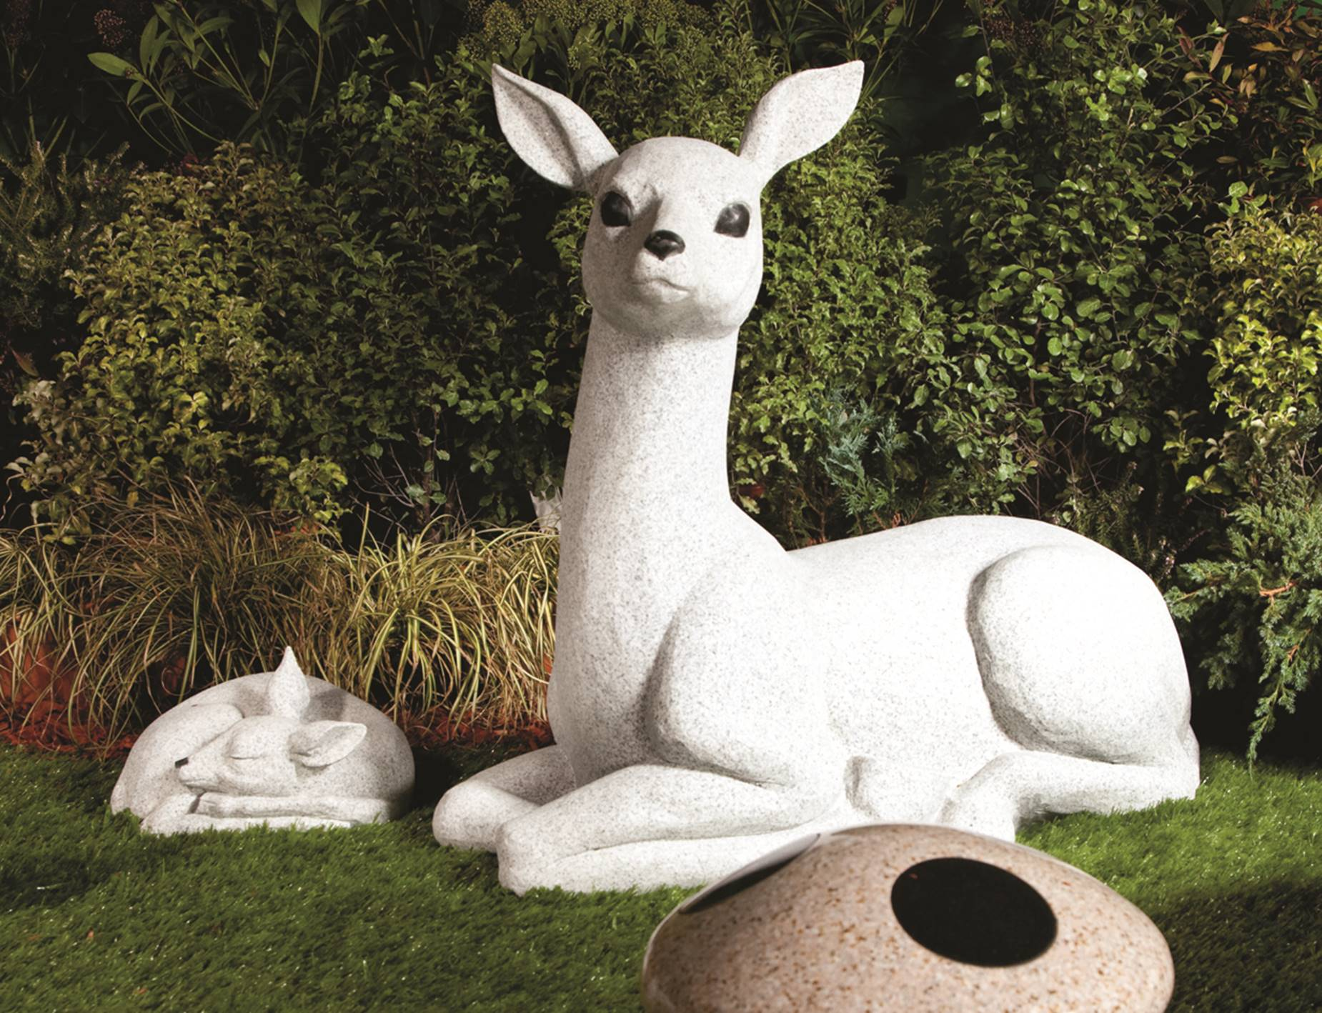

**-------------------------------------------------------------------------------------**

**Your details**

**I would like to lease a mushroom memorial**

**I understand** that on completion of the term of the lease, I have the option to extend. The inscription tablet will remain the property of the family but will be removed on completion of the lease and stored if the family cannot be contacted.

|  |  |  |
| --- | --- | --- |
| **Name** |  |  |
| **Address** |  |  |
| **Phone** |  |  |
| **Email** |  |  |
| **Signature** |  |  |
| **Date** |  |  |
| **Location** |  |  |

**Please return to the cemetery clerk at Fleet Town Council, The Harlington, 236 Fleet Road, Fleet GU51 4BY. 01252 625246** [**cemetery.clerk@fleet-tc.gov.uk**](mailto:cemetery.clerk@fleet-tc.gov.uk)

HSBC Bank, Account name Fleet Town Council, sort code 40-21-27, account number 61539272. Please put your name or memorial number if known as reference