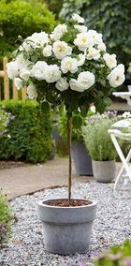**  
 Rose Memorial - with design**

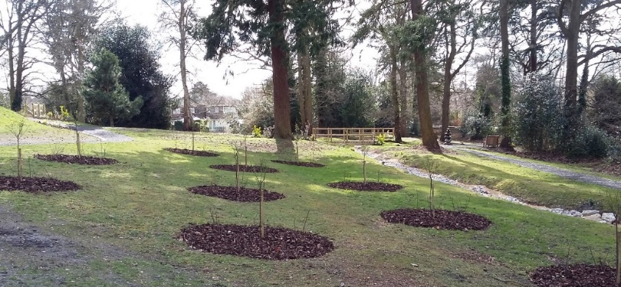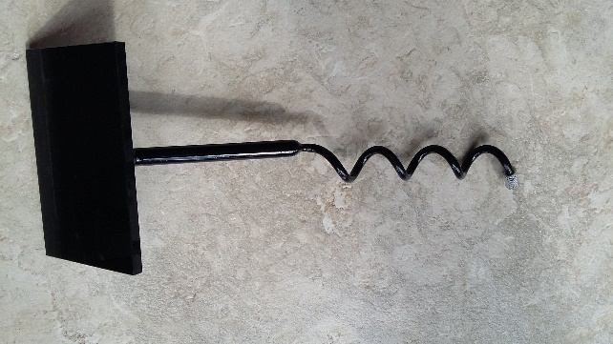

You can lease a rose bush or standard rose in our Garden of Remembrance for 15 years as a memorial to your loved one. Cremated remains can be interred in our dedicated area. Your rose will come with a granite plaque including a design with an inscription which fits in the greyed area in the box below.

We would respectfully ask that you do not place additional items, vases, etc. with the roses, as this can interfere with growth and maintenance of the rose bed. Any such items will be removed and placed in the central shelter for collection for a period of six months. If you would like to be able to place additional items, please contact the cemetery clerk to discuss alternative memorials.

**---------------------------------------------------------------------------------------------------------**

**Your inscription for the Rose Plaque 7” x 5” with design**

|  |  |  |  |  |  |  |  |  |  |  |  |  |  |  |  |  |  |  |  |  |
| --- | --- | --- | --- | --- | --- | --- | --- | --- | --- | --- | --- | --- | --- | --- | --- | --- | --- | --- | --- | --- |
|  | 1 | 2 | 3 | 4 | 5 | 6 | 7 | 8 | 9 | 10 | 11 | 12 | 13 | 14 | 15 | 16 | 17 | 18 | 19 | 20 |
| Line 1 | D | E | S | IG | N |  |  |  |  |  |  |  |  |  |  |  |  |  |  |  |
| Line 2 | T | O |  |  |  |  |  |  |  |  |  |  |  |  |  |  |  |  |  |  |
| Line 3 | G | O |  |  |  |  |  |  |  |  |  |  |  |  |  |  |  |  |  |  |
| Line 4 | H | E | R | E |  |  |  |  |  |  |  |  |  |  |  |  |  |  |  |  |
| Line 5 |  |  |  |  |  |  |  |  |  |  |  |  |  |  |  |  |  |  |  |  |
| Line 6 |  |  |  |  |  |  |  |  |  |  |  |  |  |  |  |  |  |  |  |  |

In order to ensure that an inscription will fit onto the Granite Tablet, please note the following information:-

1. The name uses a larger typeface than the remainder of the inscription therefore it may not exceed more than 15 letters and/or spaces per line. This is indicated by the dotted line in the guide box.
2. Lines not used for names may have a maximum of 20 smaller letters and/or spaces.
3. A maximum of two lines should be used for names. If a third line is required for a name then line 6 may not be used.
4. **DO NOT FORGET TO INCLUDE SPACES IN YOUR INSCRIPTION.** A space counts as a letter or number.
5. We will centre the text on the tablet; this guide box is only to aid your choice of inscription.
6. The inscription **MUST** be clearly written in block capitals. ***We are unable to accept responsibility for any incorrect inscription due to illegible or ambiguous writing.***





A full range of artwork designs are available - floral, hobbies, animals, sports. We can also provide bespoke artwork based on your design in order to recognise a special interest, celebration or passion of your loved one. Award winning artists and craftsmen ensure your design is reproduced to the highest standard

The photo plaque allows you to create a personal legacy when you add ceramic portraits to your tribute. The high-quality process ensures that the ceramic cameos retain their beauty indefinitely.

**-------------------------------------------------------------------------------------**

**Your details**

**I would like to lease a Rose bush or Standard Rose (*delete as appropriate)**

I confirm that I will not place additional items, vases, etc. with the roses, as this can interfere with growth and maintenance of the rose bed. Any such items will be removed and placed in the central shelter for collection

At the end of the 15 years, the lease can be extended for a further 15 years (or multiples of). I agree that at the end of the lease period, if no contact can be made with the family, the plaque will be removed from the rose and stored.

|  |  |  |
| --- | --- | --- |
| **Name** |  |  |
| **Address** |  |  |
| **Phone** |  |  |
| **Email** |  |  |
| **Signature** |  |  |
| **Date** |  |  |
| **Rose Number** |  |  |

**Please return to the cemetery clerk at Fleet Town Council, The Harlington, 236 Fleet Road, Fleet GU51 4BY. 01252 625246** [**cemetery.clerk@fleet-tc.gov.uk**](mailto:cemetery.clerk@fleet-tc.gov.uk)

HSBC Bank, Account name Fleet Town Council, sort code 40-21-27, account number 61539272. Please put your name or memorial number if known as reference

**Rose Memorial - plain**

You can lease a rose bush or standard rose in our Garden of Remembrance for 15 years as a memorial to your loved one. Cremated remains can be interred in our dedicated area. Your rose will come with a standard plaque with an inscription which fits in the box below.

We would respectfully ask that you do not place additional items, vases, etc. with the roses, as this can interfere with growth and maintenance of the rose bed. Any such items will be removed and placed in the central shelter for collection for a period of six months. If you would like to be able to place additional items, please contact the cemetery clerk to discuss alternative memorials.

**---------------------------------------------------------------------------------------------------------**

**Your inscription for the Rose 6” x 4” Plaque on spiral**

|  |  |  |  |  |  |  |  |  |  |  |  |  |  |  |  |  |
| --- | --- | --- | --- | --- | --- | --- | --- | --- | --- | --- | --- | --- | --- | --- | --- | --- |
|  | 1 | 2 | 3 | 4 | 5 | 6 | 7 | 8 | 9 | 10 | 11 | 12 | 13 | 14 | 15 | 16 |
| Line 1 |  |  |  |  |  |  |  |  |  |  |  |  |  |  |  |  |
| Line 2 |  |  |  |  |  |  |  |  |  |  |  |  |  |  |  |  |
| Line 3 |  |  |  |  |  |  |  |  |  |  |  |  |  |  |  |  |
| Line 4 |  |  |  |  |  |  |  |  |  |  |  |  |  |  |  |  |
| Line 5 |  |  |  |  |  |  |  |  |  |  |  |  |  |  |  |  |
| Line 6 |  |  |  |  |  |  |  |  |  |  |  |  |  |  |  |  |

# In order to ensure that an inscription will fit onto the 6” x 4” Tablet on Spiral, please note the following information:-

1. The name uses a larger typeface than the remainder of the inscription and therefore it may not exceed more than 16 letters and/ or spaces per line. The name should be confined to the top 2 lines.
2. A maximum of two lines should be used for names. If a third line is required for a name then line 5 may not be used.
3. **DO NOT FORGET TO INCLUDE SPACES IN YOUR INSCRIPTION.** A space counts as a letter or number.
4. We will centre the text on the tablet; this guide box is only to aid your choice of inscription.
5. The inscription **MUST** be clearly written in block capitals. ***We are unable to accept responsibility for any incorrect inscription due to illegible or ambiguous writing.***

**-------------------------------------------------------------------------------------**

**Your details**

**I would like to lease a Rose bush or Standard Rose (*delete as appropriate)**

I confirm that I will not place additional items, vases, etc. with the roses, as this can interfere with growth and maintenance of the rose bed. Any such items will be removed and placed in the central shelter for collection for a period of six months

At the end of the 15 years, the lease can be extended for a further 15 years (or multiples of). I agree that at the end of the lease period, if no contact can be made with the family, the plaque will be removed from the rose and stored.

|  |  |  |
| --- | --- | --- |
| **Name** |  |  |
| **Address** |  |  |
| **Phone** |  |  |
| **Email** |  |  |
| **Signature** |  |  |
| **Date** |  |  |
| **Rose Number** |  |  |

**Please return to the cemetery clerk at Fleet Town Council, The Harlington, 236 Fleet Road, Fleet GU51 4BY. 01252 625246** [**cemetery.clerk@fleet-tc.gov.uk**](mailto:cemetery.clerk@fleet-tc.gov.uk)

HSBC Bank, Account name Fleet Town Council, sort code 40-21-27, account number 61539272. Please put your name or memorial number if known as reference