**  
 Sanctum 2000 Memorial Vault**

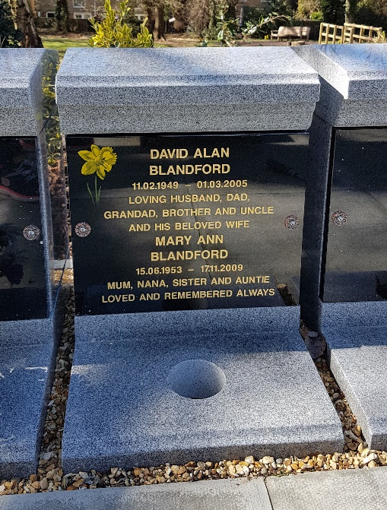

Sanctum 2000 memorial vaults can be leased and offer a resting place for the cremated remains of 2 people. Each polished granite vault has a black granite tablet, engraved inscription in gold, together with a choice of photo or artwork, plus a vase for your flowers. A flower vase is provided for the placement of cut flowers.

We would respectfully ask that you do not place additional items, vases, etc. on or near the vaults. Any such items will be removed and placed in the central shelter for collection for a period of 6 months.

**---------------------------------------------------------------------------------------------------------**

**Your inscription for the Memorial Vault Plaque**

|  |  |  |  |  |  |  |  |  |  |  |  |  |  |  |  |  |  |  |  |  |  |  |  |  |  |
| --- | --- | --- | --- | --- | --- | --- | --- | --- | --- | --- | --- | --- | --- | --- | --- | --- | --- | --- | --- | --- | --- | --- | --- | --- | --- |
| **Guidelines to help you with your choice of Inscription** | | | | | | | | | | | | | | | | | | | | | | | | | |
| The name uses larger typeface, so it cannot exceed more than 18 letters & spaces per line (name will be centred)  Please note there is only enough height for 3 name lines – if more space is required, fewer lines must be used.  All other lines may have up to 25 letters and spaces per line. Remember to include spaces – a space counts as a letter or number. The blacked out areas indicate where the fixing holes go, so these boxes cannot be used.  If a design or photo is to be included, the shaded area (in the first four lines) must be left free. | | | | | | | | | | | | | | | | | | | | | | | | | |
| Inscription guide box for memorial vault | | | | | | | | | | | | | | | | | | | | | | | | | |
|  | 1 | 2 | 3 | 4 | 5 | 6 | 7 | 8 | 9 | 10 | 11 | 12 | 13 | 14 | 15 | 16 | 17 | 18 | 19 | 20 | 21 | 22 | 23 | 24 | 25 |
| Line 1 |  |  |  |  |  |  |  |  |  |  |  |  |  |  |  |  |  |  |  |  |  |  |  |  |  |
| Line 2 |  |  |  |  |  |  |  |  |  |  |  |  |  |  |  |  |  |  |  |  |  |  |  |  |  |
| Line 3 |  |  |  |  |  |  |  |  |  |  |  |  |  |  |  |  |  |  |  |  |  |  |  |  |  |
| Line 4 |  |  |  |  |  |  |  |  |  |  |  |  |  |  |  |  |  |  |  |  |  |  |  |  |  |
| Line 5 |  |  |  |  |  |  |  |  |  |  |  |  |  |  |  |  |  |  |  |  |  |  |  |  |  |
| Line 6 |  |  |  |  |  |  |  |  |  |  |  |  |  |  |  |  |  |  |  |  |  |  |  |  |  |
| Line 7 |  |  |  |  |  |  |  |  |  |  |  |  |  |  |  |  |  |  |  |  |  |  |  |  |  |
| Line 8 |  |  |  |  |  |  |  |  |  |  |  |  |  |  |  |  |  |  |  |  |  |  |  |  |  |
| Line 9 |  |  |  |  |  |  |  |  |  |  |  |  |  |  |  |  |  |  |  |  |  |  |  |  |  |
| Line 10 |  |  |  |  |  |  |  |  |  |  |  |  |  |  |  |  |  |  |  |  |  |  |  |  |  |
| Line 11 |  |  |  |  |  |  |  |  |  |  |  |  |  |  |  |  |  |  |  |  |  |  |  |  |  |





A full range of artwork designs are available - floral, hobbies, animals, sports. We can also provide bespoke artwork based on your design in order to recognise a special interest, celebration or passion of your loved one. Award winning artists and craftsmen ensure your design is reproduced to the highest standard

The photo plaque allows you to create a personal legacy when you add ceramic portraits to your tribute. The high-quality process ensures that the ceramic cameos retain their beauty indefinitely.

The Sanctum memorial can be leased for 25 years or 50 years with an option to extend after that. The above ground vaults allow you the flexibility to remove the cremated remains should the family relocate to a different area and you wish to take the cremated remains of your loved one with you.

**-------------------------------------------------------------------------------------**

**Your details**

**I would like to lease a Sanctum 2000 Memorial Vault for a period of 25 / 50* years.**

**I understand that flowers may only be placed in the vase provided and that any other flowers, plants or items left on the Memorial Vault will be removed. Anything placed on the granite could damage the porous surface. Non-biodegradable urns must be used in the Sanctums**

**I agree that at the end of the lease period, if no contact can be made with the family, after 6 months, the cremated remains will be removed from the vault and scattered in our dedicated area and the container disposed of.**

|  |  |  |
| --- | --- | --- |
| **Name** |  |  |
| **Address** |  |  |
| **Phone** |  |  |
| **Email** |  |  |
| **Signature** |  |  |
| **Date** |  |  |
| **Vault number** |  |  |

**Please return to the cemetery clerk at Fleet Town Council, The Harlington, 236 Fleet Road, Fleet GU51 4BY. 01252 625246** [**cemetery.clerk@fleet-tc.gov.uk**](mailto:cemetery.clerk@fleet-tc.gov.uk)

HSBC Bank, Account name Fleet Town Council, sort code 40-21-27, account number 61539272. Please put your name or memorial number if known as reference