ASHES PLOT LOCATIONS

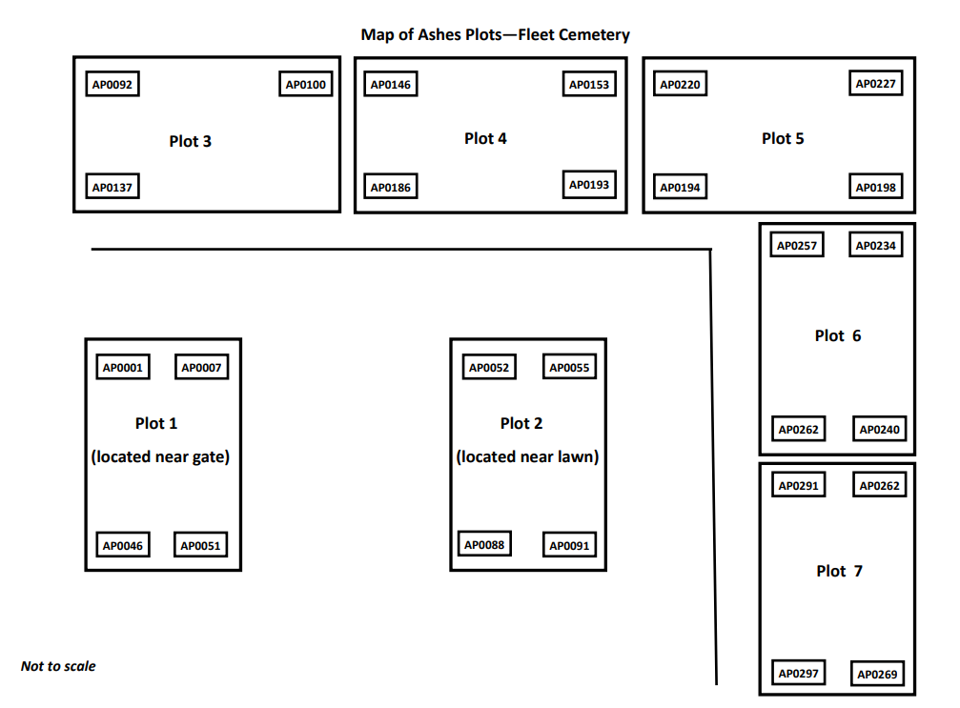

AP0001 | AP0002 | AP0003 | AP0004 | AP0005 | AP0006 | AP0007
AP0008 | AP0009 | AP0010 | AP0011 | AP0012 | AP0013 | AP0014
AP0015 | AP0016 | AP0017 | AP0018 | AP0019 | AP0020 | AP0021
AP0022 | AP0023 | AP0024 | AP0025 | AP0026 | AP0027
AP0028 | AP0029 | AP0030 | AP0031 | AP0032 | AP0033
AP0034 | AP0035 | AP0036 | AP0037 | AP0038 | AP0039
AP0040 | AP0041 | AP0042 | AP0043 | AP0044 | AP0045
AP0046 | AP0047 | AP0048 | AP0049 | AP0050 | AP0051

ASHES PLOT 1

AP0052 | AP0053 | AP0054 | AP0055
AP0056 | AP0057 | AP0058 | AP0059
AP0060 | AP0061 | AP0062 | AP0063
AP0064 | AP0065 | AP0066 | AP0067
AP0068 | AP0069 | AP0070 | AP0071
AP0072 | AP0073 | AP0074 | AP0075
AP0076 | AP0077 | AP0078 | AP0079
AP0080 | AP0081 | AP0082 | AP0083
AP0084 | AP0085 | AP0086 | AP0087
AP0088 | AP0089 | AP0090 | AP0091
ASHES PLOT 2

ASHES PLOT 3

AP092 | AP093 | AP094 | AP095 | AP096 | AP097 | AP098 | AP099 | AP0100
AP0101 | AP0102 | AP0103 | AP0104 | AP0105 | AP0106 | AP0107 | AP0108 | AP0109
AP0110 | AP0111 | AP01112 | AP0113 | AP0114 | AP0115 | AP0116 | AP0117 | AP0118
AP0119 | AP0120 | AP01121 | AP0122 | AP0123 | AP0124 | AP0125 | AP0126 | AP0127
AP0128 | AP0129 | AP01130 | AP0131 | AP0132 | AP0133 | AP0134 | AP0135 | AP0136
AP0137 | AP0138 | AP01139 | AP0140 | AP0141 | AP0142 | AP0143 | AP0144 | AP0145

ASHES PLOT 4
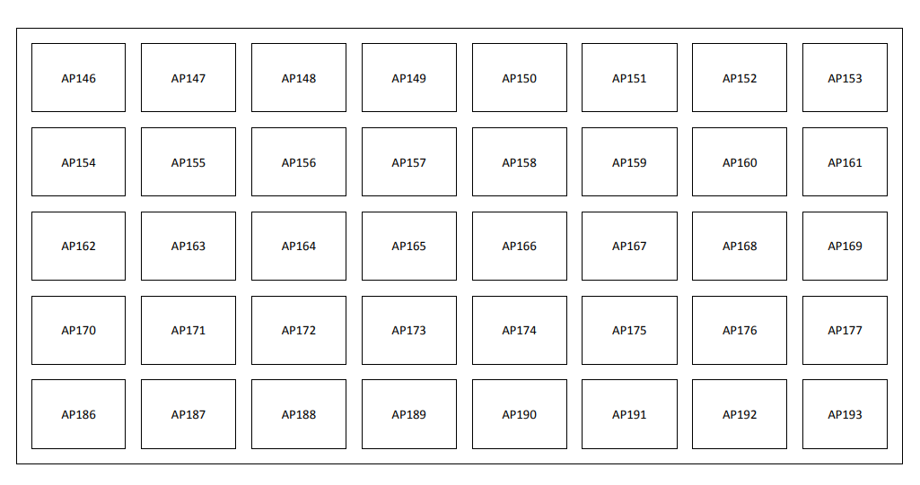

ASHES PLOT 5

AP0220 | AP0221 | AP0222 | AP0223 | AP0224 | AP0225 | AP0226 | AP0227
AP0213 | AP0214 | AP0215 | AP0216 |  | AP0217 | AP0218 | AP0219
AP0206 | AP0207 | AP0208 | AP0209 |  | AP0210 | AP0211 | AP0212
AP0199 | AP0200 | AP0201 | AP0202 |  | AP0203 | AP0204 | AP0205
AP0194 |  | AP0192 | AP0195 |  | AP0196 | AP0197 | AP0198

ASHES PLOT 6
AP0234  Ecker | AP0235 | AP0236 | AP0237 | AP0238 | AP0239  Bryan | AP0240  Bryan  (res)
AP0241  Duffell | AP0242  Duffell | AP0243  Clilverd | AP0244  Jarrett | AP0245  Jarrett | AP0246 | Tree root
AP0247  Freda Duffell | AP0248  Duffell | AP0249  Clilverd/Machon | AP0250  Jackson  Res | AP0251  Kicks | Tree root
AP0252  Res  Clarke | AP0253  Droppa | AP0254  Brown  Res | AP0255  Batts | AP0256  Hall | Tree root
 | AP0257  Weait | AP0258  Tilson | AP0259  Colin White | AP0260  Douglas White | AP0261  Gordon | AP0216A  Ramsey  (res)

ASHES PLOT 7
AP0262 | AP0263  Cox | AP0264  Cioboiu | AP0265  Etheridge | AP0266  Stark | AP0267  Barrett | AP0268  Hart | AP0269
Tree root | AP0270 | A0P271  Stephens | AP0272  Lapensee | AP0273  Holding | AP0274  McIntyre | AP0275  Bascran | AP0276
Tree root | AP0277  Rost | AP0278  Parker | AP0279  Butler | AP0280  Small | AP0281  Cox | AP0282  Pritchard | AP0283  Blackford
Tree root | AP0284  Beautyman | AP0285  Main | AP0286  Bore Res | AP0287  Jefford | AP0288  Wood | AP0289  Rufus Res | AP0290  Steer
 | AP0291  Clarkson | AP0292  Prince  res | AP0293  Allen  res | AP0294  Allen | AP0295  Lynch | AP0296  Williams | AP0297  Eales

